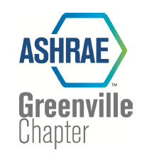
Giga-Joule

April 2023

Meeting Announcement

Technical Presentation: Green Industrial HVAC Design

The Greenville Chapter meeting will be held on Tuesday, April 11, 2023, at 11:50 PM. Registration will begin at 11:30. You can register on line at ashrae4greenville.com.

****** MEETING LOCATION ******

Total Comfort Solutions – 460 Fairforest Way, Greenville, SC 29607

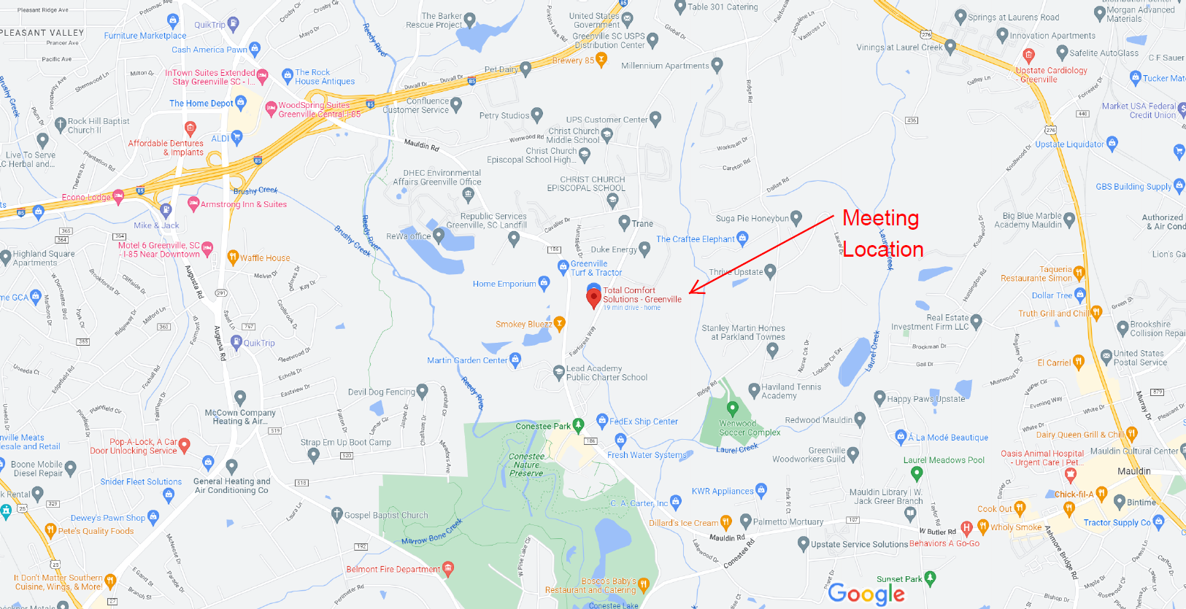

A Message from the President


Welcome to the ASHRAE FY-2022/23! Our Chapter Officers have been working hard all year to get you high quality programs and events. Thank you for all your support and participation!

Looking forward into the rest of this year as we close out strong with relevant and timely content. This month we will hear from Past ASHRAE President, Chuck Gulledge. As an ASHRAE Distinguished Lecturer, his presentation on Green Industrial HVAC Design should be very entertaining.

If there is something that we as the ASHRAE Greenville Chapter Board can to do enhance our service of Chapter Members, please do not hesitate to reach out to me or another board member (see list of board contacts & areas of service on page 7). Please also know that we are always actively looking for those that would like to volunteer to serve on the board and help steer our future direction.

We hope to see you (virtually or in person) for this month’s meeting!

Bill Knight
bknight@greenville.k12.sc.us
864-355-7792

Chapter Technology Transfer Committee
Tigue Garick



Ladies & Gentlemen,

Our chapter technology transfer committee would like to welcome you to the new year in ASHRAE. We have a great slate of programs for you this year. We will be trying Mike & Jeff’s BBQ for our meals. As always, we are looking for meeting speakers and sponsors as well as volunteers to serve on the BOG and our many committees. Please don’t hesitate to reach out to either of us with meeting ideas as well as any questions or concerns. Thank you in advance for your support of our chapter, and we look forward to seeing you next week!

Please RSVP by 9AM Monday, April 10, 2023

If you have any questions, contact:

Ryan Tonnsen 864-395-9012 or tonnsenr@cxconsultants.com

Cost: Dinner Program: $15 at door for chapter member (catered lunch)
$20 for non-chapter member (catered lunch)
$10 for virtual attendance (lunch not included)

Education Credit: This Seminar qualifies for 1.0 PDH each (including NC PE).

-------------------------

April Meeting

Charles E. Gulledge, III, PE, FASHRAE

Charles E. Gulledge III, P.E., HBDP, LEED AP, Fellow ASHRAE, was ASHRAE’s President for the 2020-21 term. His theme for the 2020-21 ASHRAE Society Year was “The ASHRAE Digital Lighthouse and Industry 4.0.” Gulledge previously served on the ASHRAE Board of Directors as president-elect, treasurer, vice president and director-at-large.

For his time and dedication to ASHRAE and the industry, he is the recipient of numerous awards including the Exceptional Service Award, Distinguished Service Award, Chapter Service Award, Regional Award of Merit, two ASHRAE Technology Awards and the Dan Mills Technology Award.
In addition to his time served on the Board of Directors, Gulledge has served as chair of Members Council and the President-Elect Advisory Committee, chair of the Finance Committee, chair of the Standards Membership Ad Hoc Committee, chair of the Development Committee for Fundraising, and as an ASHRAE Distinguished Lecturer. He has held ASHRAE Society-level leadership roles on many standing committees, technical committees, and presidential ad hoc committees.
In addition to his contributions to ASHRAE, Gulledge’s career in HVAC spans over 37 years. He entered the industry as an engineer-in-training with Parsons Brinckerhoff Quade & Douglas, working on transit system infrastructure, vehicular tunnels, and moveable swing-span bridges. Over his career, he has served the built world in the roles of a consulting engineer, municipal owner, and design-build contractor. Gulledge is currently the Director of Engineer - Construction with Environmental Air Systems, LLC. He is registered as a professional engineer in the states of North Carolina, Georgia, Kentucky, South Carolina, Alabama and Virginia.
Gulledge’s comprehensive design, construction and operational portfolio covers a variety of market sectors; including transportation, commercial, educational, institutional, lodging, sports, mission critical, life sciences, healthcare, pharmaceutical, manufacturing, industrial, archival, historical, and hospitality.
Gulledge is a 1983 graduate of North Carolina State University with a Bachelor of Science in Mechanical Engineering.

April Program
Green Industrial HVAC Design
GBCI Approved| 1 CE| 0920020148
AIA Approved| 1 LU/HSW|GIHD19
Industrial facilities present significant facility services design challenges. Resource consumption, usage, and discharge are significant. Project fundamentals are driven by process need and speed, not form response. This program identifies how green and sustainable themes can be incorporated into industrial design, construction, and operation. Content covers the following topics:
- Differentiate between integrated and conventional design methodology
- Understand scale and scalability
- Identify industrial sector project fundamentals
- Identify “Green” solutions for industrial scale projects
- Assemble an IBD work tea

The Start of a
Sustainability Committee
We will be starting a Sustainability Committee for the Greenville Chapter of ASHRAE this year. The goal of this committee is to develop projects and events that will encorage and aid in protecting the environment. We are looking for a handful of people to join this committee to aid in its development. If anyone is interested in joining this committee, please contact Brandon Guy at bguy@greenville.k12.sc.us

ASHRAE TECHNOLOGY AWARDS 2022/23 – CALL FOR NOMINATIONS!

The ASHRAE Greenville Chapter Technology Transfer Committee (CTTC) is now accepting nominations for Technology Awards. Have you or your organization done something sensational and deserve recognition? Start your application now to begin reaping the benefits of recognition by your peers and ASHRAE. There are six (6) different categories for entry. Details can be found at https://www.ashrae.org/membership/honors-and-awards/technology-awards-program-overview .

If you have any questions please contact Tigue Garick at tigueg@jmpco.com or (864)232-0200.

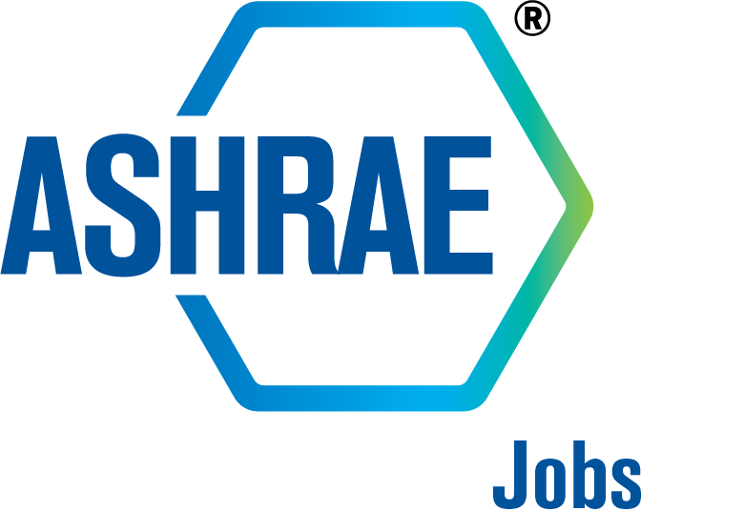Need a Job? Looking for a good candidate?
Check out the new ASHAE Job Board at https://jobs.ashrae.org/

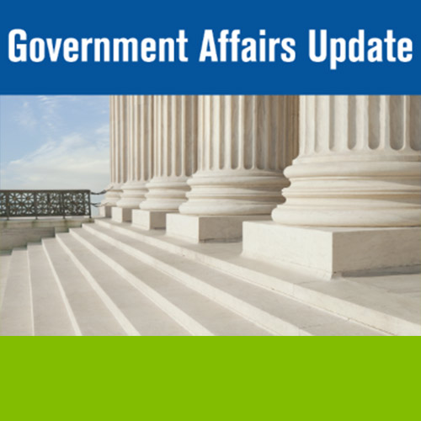
ASHRAE GAC Position Papers - https://www.ashrae.org/about/position-documents

Include this link in the GAC Update - https://www.magnetmail.net/Actions/email_web_version.cfm?publish=newsletter&user_id=ASHRAE&message_id=22541270

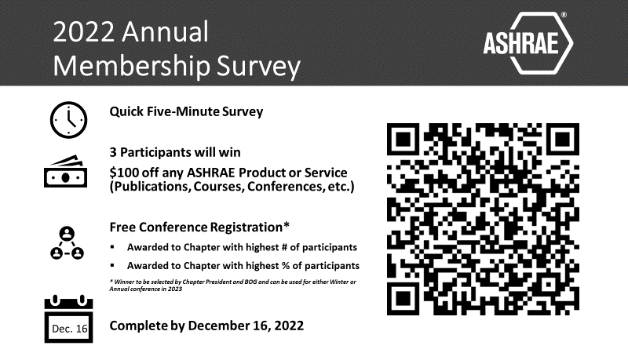
ASHRAE Greenville Chapter Board

Chapter President | Bill Knight
Chapter President Elect | Matthew Lewis
Chapter Vice President | Brandon Guy
Chapter Secretary | Jeremy Butdorf
Chapter Treasurer | Ryan Tonnsen
Chapter Board of Governors | Devon Cortright
Chapter Board of Governors | Karl Counts
Chapter Board of Governors | Tigue Garick
Chapter Communications Chair | Matthew Lewis
Chapter Technology Transfer Chair | Tigue Garick
Chapter Membership Promotion Chair | Brandon Dillard
Chapter Research Promotion Chair | Joe Holman
Chapter Student Activities Chair | Matt Lewis/Brandon Guy
Chapter Grassroots Government Activities Chair | Rodney Hinton
Chapter Historian | Brandon Guy
Chapter Honors and Awards | Devon D Cortright
Chapter Webmaster | Karl F Counts
YEA Chair | Matthew Lewis

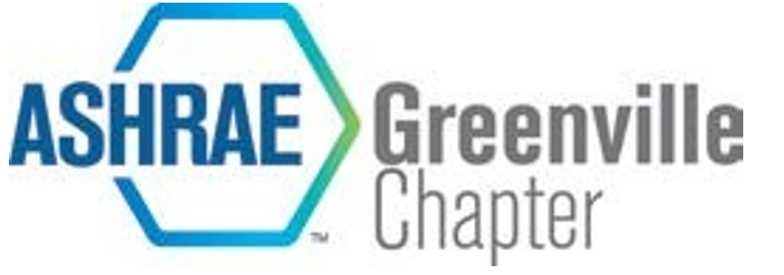 |  | Event Dates for 2022-2023
Date | Topic |  | Special Emphasis | Location | Presenter
Tuesday 09/13/2022 | Direct Fired Heating |  |  | Total Comfort Solutions  406 Fairforest Way,  Greenville, SC | Cambridge  Spencer Jerome
Tuesday 10/11/2022 | SC Building Codes Update |  | Research Promotion | Total Comfort Solutions  406 Fairforest Way,  Greenville, SC | Delisa Clark
Tuesday 11/08/2022 | VRF & Hydronic Systems Comparison |  | Joint Meeting / MCA | Total Comfort Solutions  406 Fairforest Way,  Greenville, SC | Xylem  Kyle Delpiano
Tuesday 12/13/2022 | Wind and Seismic Restraint |  | Membership Promotion | Total Comfort Solutions  406 Fairforest Way,  Greenville, SC | Kinetics  Lee Chiddention
Tuesday 01/10/2023 | TBD |  |  | Total Comfort Solutions  406 Fairforest Way,  Greenville, SC
Tuesday 02/14/2023 | SC Air Legal Update and  Air Pollution Case Studies |  |  | Total Comfort Solutions  406 Fairforest Way,  Greenville, SC | Gene C. McCall
Tuesday 03/14/2023 | Hydronic Systems & Decarbonization |  | ASH-BASH | Brewery 85  Greenville, SC | Chris Edmondson
Tuesday 04/11/2023 | Green Industrial Design |  |  | Total Comfort Solutions  406 Fairforest Way,  Greenville, SC | Chuck Gulledge
Tuesday 05/09/2023 | Std. 185.3 |  |  | Total Comfort Solutions  406 Fairforest Way,  Greenville, SC | Jim Reidenhour
Tuesday 06/13/2023 | Updates |  |  | Total Comfort Solutions  406 Fairforest Way,  Greenville, SC

