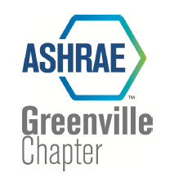
Giga-Joule

March 2023

Meeting Announcement

Technical Presentation: Hydronic Systems for Decarbonization and Low EUI

The Greenville Chapter meeting will be held on Tuesday, March 14, 2023, at 6:00 PM. Registration will begin at 6:00. You can register on line at ashrae4greenville.com.
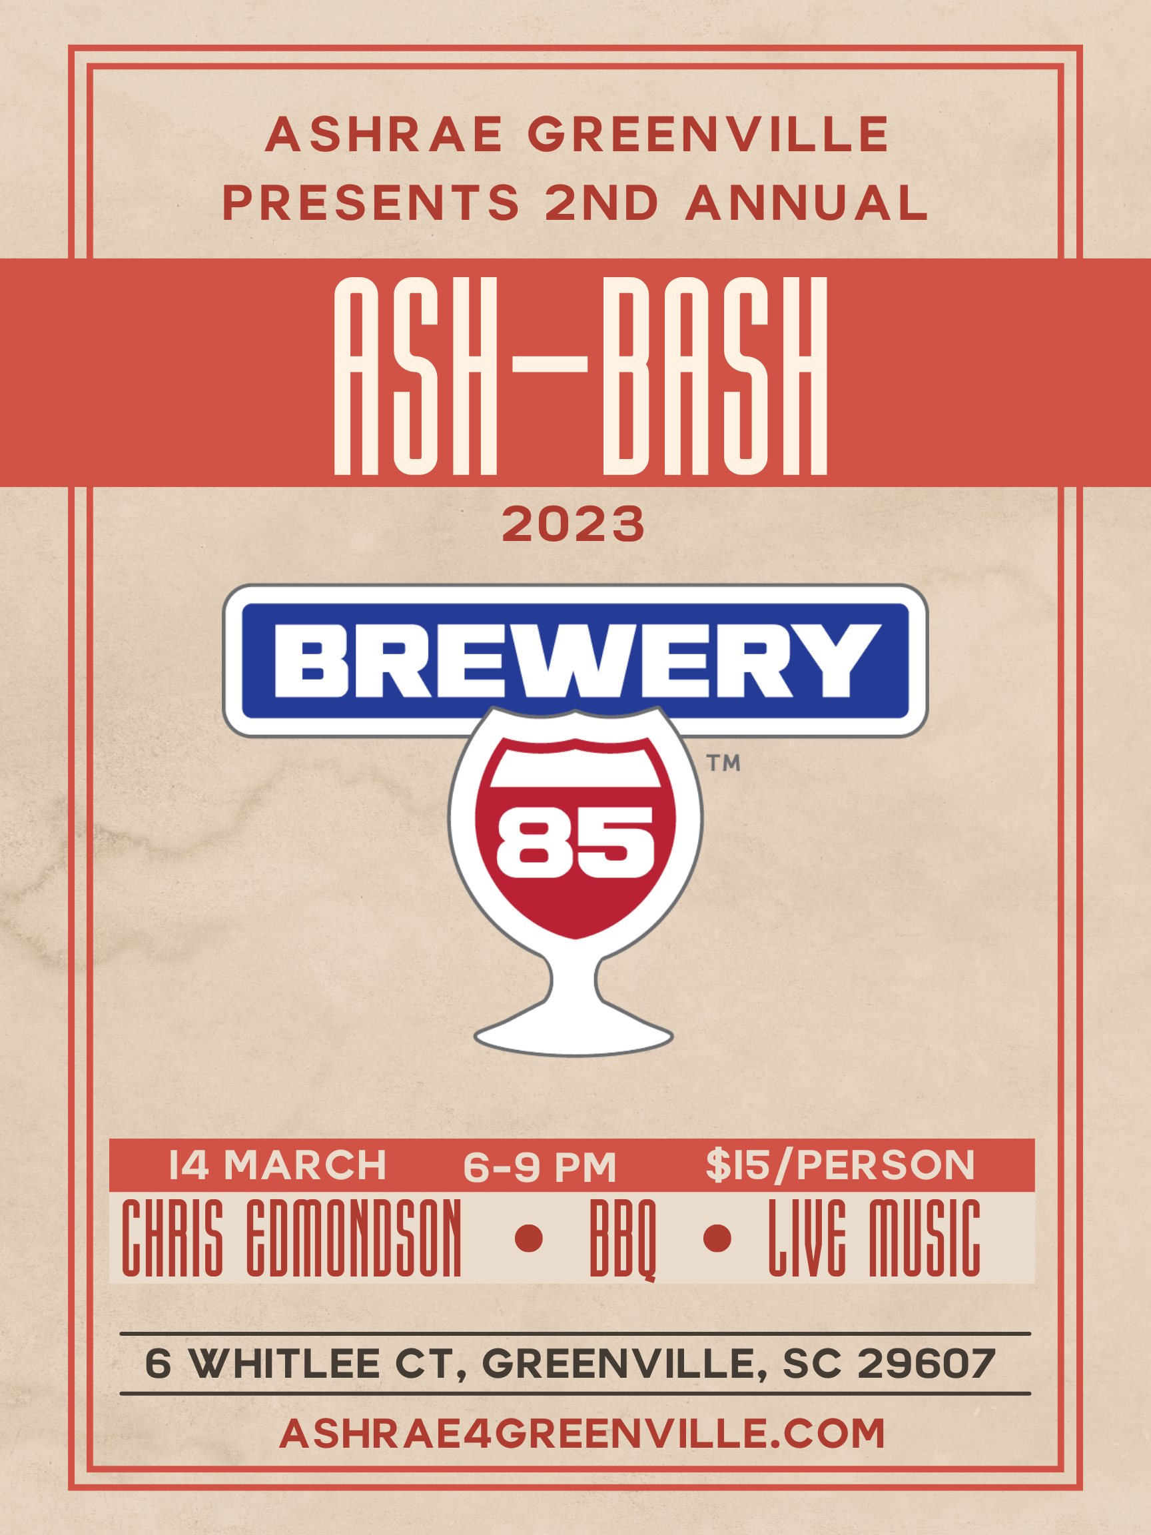
A Message from the President

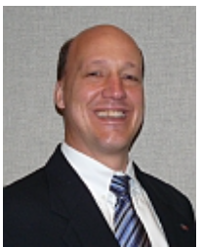
Welcome to the ASHRAE FY-2022! Our Chapter Officers have been working hard to get you high quality programs and events for the year. Thank you for all your support and participation last year.

Looking forward into the rest of this year we have several events planned that you will

rtually.

If there is something that we as a ASHRAE Greenville Chapter Board can to do enhance our service of Chapter Members, please do not hesitate to reach out to me or another board member (see list of board contacts & areas of service on page 4). Please also know that we are always actively looking for those that would like to volunteer to serve on the board and help steer our future direction.

We hope to see you (virtually or in person) for this month’s meeting!

Bill Knight
bknight@greenville.k12.sc.us
864-355-7792

Chapter Technology Transfer Committee
Tigue Garick



Ladies & Gentlemen,

Our chapter technology transfer committee would like to welcome you to the new year in ASHRAE. We have a great slate of programs for you this year. We will be trying Mike & Jeff’s BBQ for our meals. As always, we are looking for meeting speakers and sponsors as well as volunteers to serve on the BOG and our many committees. Please don’t hesitate to reach out to either of us with meeting ideas as well as any questions or concerns. Thank you in advance for your support of our chapter, and we look forward to seeing you next week!

Please RSVP by 9AM Monday, March 13, 2023

If you have any questions, contact:

Ryan Tonnsen 864-395-9012 or tonnsenr@cxconsultants.com

Cost: Dinner Program: $15 at door for chapter member (catered lunch)
$20 for non-chapter member (catered lunch)
$10 for virtual attendance (lunch not included)

Education Credit: This Seminar qualifies for 1.0 PDH each (including NC PE).
-------------------------

March Meeting

This month’s chapter program will give us the opportunity to learn more about hydronic systems and how they can be used to achieve decarbonization and low EUI. The learning objectives of this meeting are as follows:
- At a high level to understand the key factors driving future building decarbonization and the electrification of building HVAC design
- Why a low site EUI (Energy Use Intensity) building design will become mandatory
- Why hydronic heating and cooling with storage is desirable
- Why air and water source heat pumps with high COPs for cooling, heating and domestic water will become standard go to system to reduce Source EUI.
Speaker Chris Edmondson received his B.S. Degree in Mechanical Engineering from North Carolina State University in 1967. After graduation, he spent four and a half years as a salesman with the Trane Company. In 1971, he came to work for the James M. Pleasants Co., Inc. He worked as an Outside Salesman until 1978, when he was promoted to Vice President and Sales Manager till 1987. From 1987 to 2010, he has served as President of the Pleasants Company. Chris is currently CEO of James M. Pleasants Company.

Special Emphasis – Membership Promotion
******Employer Recognition******

A special thanks to all our employers supporting our members


What: 2-Person Team Captains Choice Golf Tournament, Putting Course, and Dinner with proceeds going towards ASHRAE Research Promotion. There will be prizes for teams winning 1st, 2nd, 3rd place and other opportunities for closest to the pin and 3’s - 17,000 sqft St. Andrews inspired putting course. Individuals are responsible for their clubs, golf balls, and beverages. Golf will be under the lights, no specialty golf balls required. Max 24 Teams, so sign-up to ensure you will not miss out on a fun event. Please contact Joe Holman: Joe.Holman@trane.com with any questions.
When: Thursday – March 9th.
Where: 3’s Greenville Golf & Grill – 61 Villa Rd, Greenville, SC 29615

The Start of a
Sustainability Committee
We will be starting a Sustainability Committee for the Greenville Chapter of ASHRAE this year. The goal of this committee is to develop projects and events that will encorage and aid in protecting the environment. We are looking for a handful of people to join this committee to aid in its development. If anyone is interested in joining this committee, please contact Brandon Guy at bguy@greenville.k12.sc.us

ASHRAE TECHNOLOGY AWARDS 2022/23 – CALL FOR NOMINATIONS!

The ASHRAE Greenville Chapter Technology Transfer Committee (CTTC) is now accepting nominations for Technology Awards. Have you or your organization done something sensational and deserve recognition? Start your application now to begin reaping the benefits of recognition by your peers and ASHRAE. There are six (6) different categories for entry. Details can be found at https://www.ashrae.org/membership/honors-and-awards/technology-awards-program-overview .

If you have any questions please contact Tigue Garick at tigueg@jmpco.com or (864)232-0200.

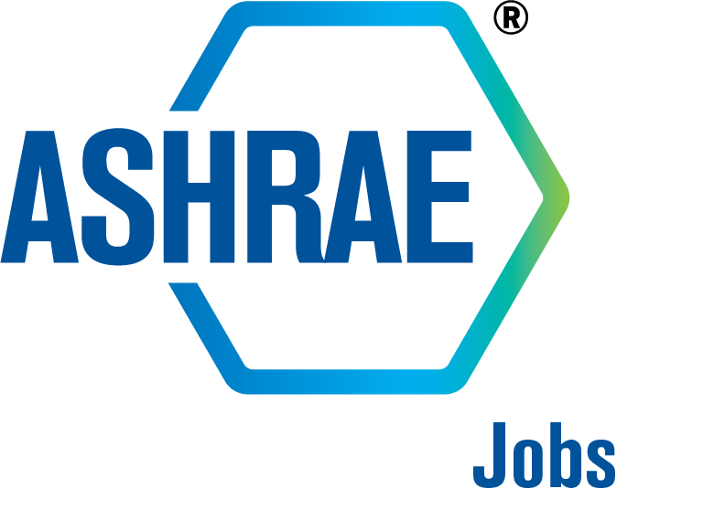Need a Job? Looking for a good candidate?
Check out the new ASHAE Job Board at https://jobs.ashrae.org/

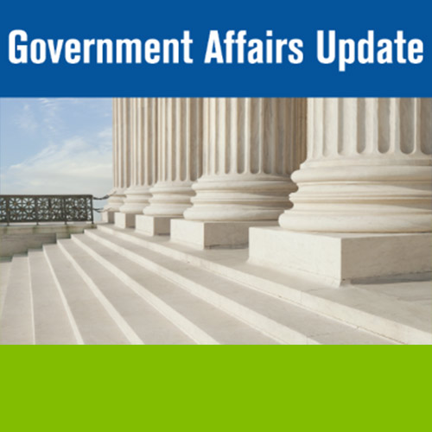
ASHRAE GAC Position Papers - https://www.ashrae.org/about/position-documents

Include this link in the GAC Update - https://www.magnetmail.net/Actions/email_web_version.cfm?publish=newsletter&user_id=ASHRAE&message_id=22541270

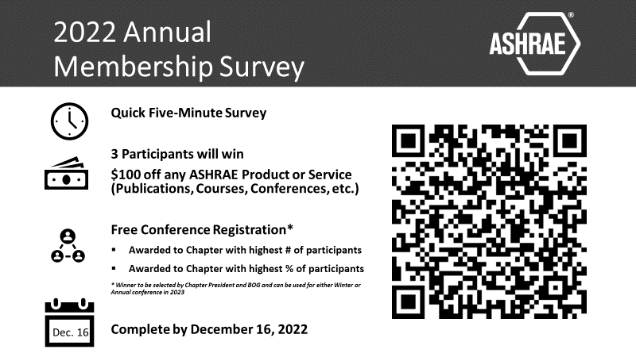
ASHRAE Greenville Chapter Board

Chapter President | Bill Knight
Chapter President Elect | Matthew Lewis
Chapter Vice President | Brandon Guy
Chapter Secretary | Jeremy Butdorf
Chapter Treasurer | Ryan Tonnsen
Chapter Board of Governors | Devon Cortright
Chapter Board of Governors | Karl Counts
Chapter Board of Governors | Tigue Garick
Chapter Communications Chair | Matthew Lewis
Chapter Technology Transfer Chair | Tigue Garick
Chapter Membership Promotion Chair | Brandon Dillard
Chapter Research Promotion Chair | Joe Holman
Chapter Student Activities Chair | Matt Lewis/Brandon Guy
Chapter Grassroots Government Activities Chair | Rodney Hinton
Chapter Historian | Brandon Guy
Chapter Honors and Awards | Devon D Cortright
Chapter Webmaster | Karl F Counts
YEA Chair | Matthew Lewis

 |  | Event Dates for 2022-2023
Date | Topic |  | Special Emphasis | Location | Presenter
Tuesday 09/13/2022 | Direct Fired Heating |  |  | Total Comfort Solutions  406 Fairforest Way,  Greenville, SC | Cambridge  Spencer Jerome
Tuesday 10/11/2022 | SC Building Codes Update |  | Research Promotion | Total Comfort Solutions  406 Fairforest Way,  Greenville, SC | Delisa Clark
Tuesday 11/08/2022 | VRF & Hydronic Systems Comparison |  | Joint Meeting / MCA | Total Comfort Solutions  406 Fairforest Way,  Greenville, SC | Xylem  Kyle Delpiano
Tuesday 12/13/2022 | Wind and Seismic Restraint |  | Membership Promotion | Total Comfort Solutions  406 Fairforest Way,  Greenville, SC | Kinetics  Lee Chiddention
Tuesday 01/10/2023 | TBD |  |  | Total Comfort Solutions  406 Fairforest Way,  Greenville, SC
Tuesday 02/14/2023 | SC Air Legal Update and  Air Pollution Case Studies |  |  | Total Comfort Solutions  406 Fairforest Way,  Greenville, SC | Gene C. McCall
Tuesday 03/14/2023 | Hydronic Systems & Decarbonization |  | ASH-BASH | Brewery 85  Greenville, SC | Chris Edmondson
Tuesday 04/11/2023 | Green Industrial Design |  |  | Total Comfort Solutions  406 Fairforest Way,  Greenville, SC | Chuck Gulledge
Tuesday 05/09/2023 | Std. 185.3 |  |  | Total Comfort Solutions  406 Fairforest Way,  Greenville, SC | Jim Reidenhour
Tuesday 06/13/2023 | Updates |  |  | Total Comfort Solutions  406 Fairforest Way,  Greenville, SC

